Design Laboratory Assignment 1:
High-Altitude Scientific Balloons
ASEN 2002: Thermodynamics and Aerodynamics
Assigned: 9 September 2009
Due: 16 September, Prelab report on balloon scale model results
Due: 12 October, All Presentations due start of Lab
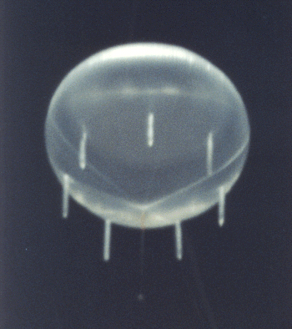
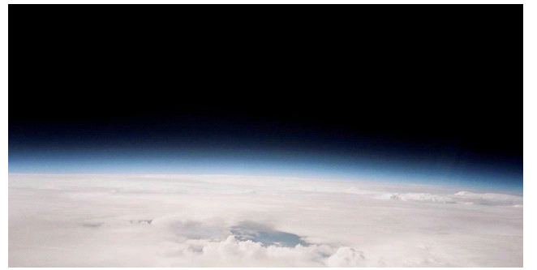
Zero pressure balloon at deployment altitude and payload camera limb view of the Earth’s
atmosphere from 30.5 km (100,000 feet)

Background and Introduction

Balloon Design: An Application of the Ideal Gas Law and First Law
There are only two practical methods of producing a buoyant aircraft. If the air inside a suitably large and lightweight envelope is heated to a high temperature, the gas expands and a sufficient amount of fluid (air can be considered a fluid) may be forced out of the interior so that its weight decreases and the total weight of the craft becomes less than the amount of fluid (or air) displaced. Hot air balloons were flown by the brothers Joseph and Etienne Montgolfier as early as the spring of 1783. While the materials and technology are very different, the principles used by the earliest eighteenth-century experimenters continue to carry modern sport balloons aloft.
The other means of achieving buoyant flight is to fill the envelope with a gas that is sufficiently lighter than air. The first hydrogen-filled balloon was designed and constructed by Jacques A.C. Charles and launched from the Champs de Mars in Paris on August 27, 1783. Jean Pierre Blanchard, a French aeronaut, made the first free flight with a gas balloon in the United States from Philadelphia in January 1793.
Today, research balloons capable of reaching high-altitudes (>30 km) for extended periods of time (weeks to months) are being deployed by NASA. These balloons carry research payloads that enable scientific measurements that are otherwise hindered on the ground by atmospheric effects. These balloons also serve to test spacecraft instrumentation prior to satellite deployment while mitigating the significant forces incurred during launch.
Scientists use scientific data collected during balloon flights to help answer important questions about the universe, atmosphere, the Sun and the space environment. Questions such as "How did the universe, galaxies, stars, and planets form and evolve?" and "Are there Earth-like planets beyond our solar system?" are being answered by NASA with the help of experiments flown on scientific ballons.
There are two types of research balloons: zero-pressure balloons and super-pressure balloons. A more appropriate name would be zero-pressure gradient balloons and super-pressure gradient balloons but the word “gradient” is commonly dropped or implied.
The most basic design question about high-altitude balloons is how to achieve and maintain a desired altitude for a given instrument payload. This needs to take into account the following issues:
- The density, pressure and temperature conditions of the atmosphere.
- The Ideal Gas Law and Archimede’s Principle.
- The diurnal cycle of radiative flux
- Material properties.and their design limits
- The complexity, cost and mass of the type of material chosen for the balloon.

Scale Model Balloon System
Prior to developing a design for a high-altitude research balloon, your task is to build a scale model of a zero-pressure balloon and develop a mechanical and thermal assessment of the system.

Construct a helium balloon with payload. Gather all balloon material and determine their mass. With the assistance of a lab technician, fill the balloon with helium gas. Record the estimated mass of gas for your system – note this source has a large uncertainty. Attach a payload and acheive neutral buoyancy in the lab. Draw a free-body diagram of the system and perform a force analysis identifying all forces involved. Record local temperature and pressure from ITLL reading or website.

Make your balloon “slightly” negatively buoyant. Add additional payload to your balloon to make it fall. Place the balloon system in front of a heater and hold it to allow sufficient time for heat to be transferred to the balloon. Release the balloon and record your observations. Define your thermal system and describe thermodynamically the processes taking place during your obervations.

Re-establish neutral buoyancy with your balloon. Record all required measurements and readings. Estimate the balloon volume by making careful measurements of the balloon dimensions. Use a water tank to provide another means of estimating balloon volume. Determine the volume of the balloon by recording the volume of water displaced in a graduated tank after fully submerging the balloon in the water tank. Contrast your tank results with your dimensional estimate for volume.

Determine the mass of the gas. Using the neutrally buoyant force balance analysis, estimate the required mass of the gas. Contrast this estimate with estimating the mass of the gas using the measured volume and the Ideal Gas Equation. Evaluate errors and discrepancy between the two estimates. Also, compare numbers with the TA’s recording of the gas flow meter. What is the total mass budget and the fractional percent of the balloon system components to the total system mass?

If you wanted to lift more payload, what design modifications would you make and what would be the impact? If you were to make your originally designed balloon neutrally buoyant in water, what would be the required mass of the payload?
Prepare a brief group report addressing all these questions and submit this report in lab on September 16.

Design a High-Altitude Balloon
In your groups perform a design analysis of a high-altitude balloon for carrying a research payload.
Your design requirements are as follows:

Payload. A 2000 kg research instrument.

Altitude. The balloon should be able to reach an altitude of 30 km

Duration. The balloon should be able to stay in residence for 2 weeks or more.

Assumptions:

Shape. Assume the shape of the balloon at target altitude is a sphere

Transients. Ignore transient effects during ascent

Stresses. Ignore stresses on balloon material associated with attaching the payload or wind loading

Zero-Pressure Gradient Balloons
Your primary analysis will involve designing a zero-pressure balloon to satisfy the clients design requirements
You should determine the following design aspects for the balloons:
- Select and support use of your internal gas – know its properties and characteristics given the expected environment
- Volume of the balloon at target altitude
- Constraints imposed by solar heating and radiative cooling
- Balloon material properties

Provide a free-body diagram and perform a force analysis of the balloon applying Archimedes Principle. Determine the lifting gas and its properties, balloon material and thickness, the final volume of the balloon, the necessary mass of your lifting gas. Provide material stress analysis to indicate possible balloon failure.

Once at altitude, account for heat transfer and work processes. Assume the sun illuminates the balloon for 12 hours while the balloon also radiates and then the next 12 hours with only the balloon radiating. Assume the only work that takes place is expansion or compression, i.e. boundary work. What is the height variation of the balloon over a 24 hour period?

Provide a design solution that would reduce the height perturbation over the 24 hour period to within 500 m of the required altitude while sustaining a duration of two weeks. The design solution does not have to be overly developed but must make sense. Remember the simpler the better, as you add complexity your solution may raise more questions and uncertainty about its appropriateness, cost, or feasibility.

Provide thermodynamic plots to illustrate the processes and various states the lifting gas experiences throughout the balloon life time.

Planetary Mission
The client would like to consider your zero-pressure balloon design for possible planetary missions. To illustrate the design modifications required, provide sensitivity plots of the following: (These sensitivity plots would include your results above but be sure to provide a range of values that straddle earth values)
- Balloon final volume versus atmospheric gas molecular weight
- Balloon height variation versus distance from the sun (Assume same atmosphere as earth so simply move the earth through the solar system)

Learning Goals
In this Design Lab, you have the opportunity to achieve the following learning goals:
- Learn about the requirements and design assumptions for developing lighter-than-air vehicles.
- Integrate your knowledge of the first law of thermodynamics in a practical design analysis. Include factors of safety, for example on material stresses, imposed by the characteristics of the design and the environment.
- Use MATLAB for plotting engineering calculations and for performing numerical integration.
- Learn trade studies and sensitivity analysis
- Learn research skills, both in the Library and on the Web.
- Further develop your team and presentation skills.
- Develop engineering reasoning skills

Required Deliverables

Group Lab Report: Due Wednesday, September 16
Your group will prepare a brief written lab report that summarizes your findings and answers questions posed for the scale model experiment performed on September 9 and described in section 1.2. The report does not need to include abstract, introduction or conclusion sections but simply a summary of the results with some discussion of the results by answering the questions.

Group Presentations: Due Monday, October 12
Your group will prepare a 15-minute presentation reporting the results of your design investigation. Include in your presentation the scale model results and your high-altitude balloon design. This report must present how each requirement is met by your design in a quantitative manner supported by analysis and research. It must also provide some rationale for your decisions.

Individual Peer Reviews
Each person must submit an email to Professor Thayer with confidential peer reviews of their team mates. This is due on the date of your final presentation. In your email, provide the following for each person in your group:
NAME: LAST, First
Technical Contribution:
Teamwork:
Communication:
Rate each of these areas 0-4, with 4=A, 3=B, 2=C. 1=D, 0=F.

Suggested Study Questions/Issues
The following statements are offered to help you clarify the issues involved in this assignment.
- The lab experiment to build a scale model of a zero-pressure balloon and develop mechanical and thermal analysis to evaluate balloon characteristics should provide some insight into the actual balloon system design.
- Research zero-pressure balloons. Formulate a “homework problem” that computes the volume of the research balloon at the required altitude – do this for a zero-pressure balloon. Discuss margins of safety before the balloon fails.
- Write a MATLAB routine that calls the function that computes the pressure, density and temperature from the 1976 Standard Atmosphere Model. A description of this atmospheric model is given in Chapter 3 of Anderson, Introduction to Flight and code can be found on the Mathworks website.
- Develop your analysis code to enable flexibility in your design parameters. That way, you can study how changes in design parameters affect the output design specifications.

Suggested Activities
You are free to organize your groups as you wish. However, we offer the following set of weekly objectives to help guide your development. Every group will probably adapt their own variation of these suggestions. You are expected to attend each laboratory session. Your group will be expected to present weekly update briefings to the faculty and staff of the class.

Week 1. Organize your groups. Brainstorm ideas. Draw pictures of the problem, to make sure you understand the parameters of the assignment. Build scale model and develop analysis. Try to distill the problem into a few equations.

Week 2. Formulate a “homework problem” for the design to compute final volume. Research needed information while others write the MATLAB code.

Week 3. Work out the radiative transfer analysis. Begin to draft your presentation. Identify missing pieces that require further work.

Week 4. Finish your presentations. Revise, revise, and revise!

Week 5. Presentations during Lab sessions. All Presentations must be submitted to the ITLL class folder by 1pm on Monday of this week.

